Assignment 2

Siemens 5G diploma

Omar Morgan

In this assignment we were trying to make an OFDM system with many noise impairments to see their effects etc and see how each components fit with each other

**BER vs SNR for different modulation schemes:**

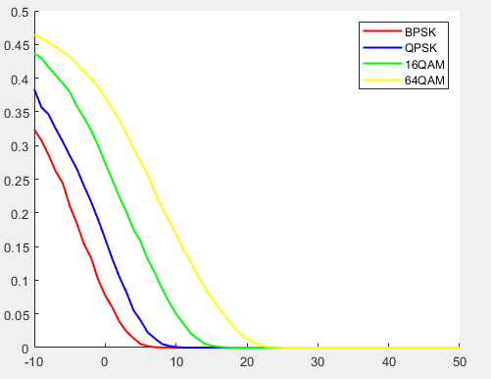

We notice that the higher the modulation scheme the worse the performance is which makes sense as the distance between them get narrower which results in worse performance

**Other blocks that were added:**

Convolutional coder and decoder: this block is responsible for correcting errors so if a bit gets flipped it gets fixed by this decoder, it managed to improve the error rate from 44% to 40% at snr equal zero.

The decoder of this block uses an algorithm called Viterbi decoding in which there are some different types of decoding like hard decoding and soft decoding which uses more information to get better performance however it was not tested out yet due to limited time.

Interleaver: The interleaver main job is to make sure that we don’t get burst errors which means that if you were using your phone and crossed under a tunnel there is a higher chance that all those bits would fail thus even with proper error correction code you wouldn’t be able to get the signal back which is quite sad indeed, thus the interleaver was added to help mitigate those type of errors

**Channel Impairments:**

Frequency offset effect:

DC offset effect:

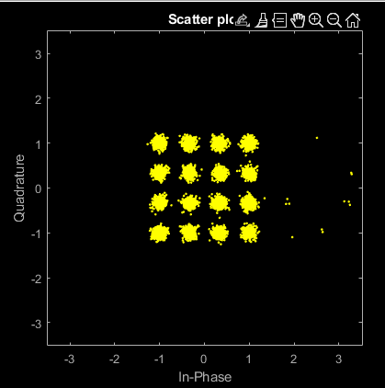

Effect without equalizing the signal:

For normalized offset 0.01:

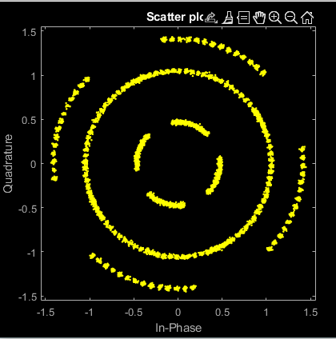

For normalized offset 0.05:

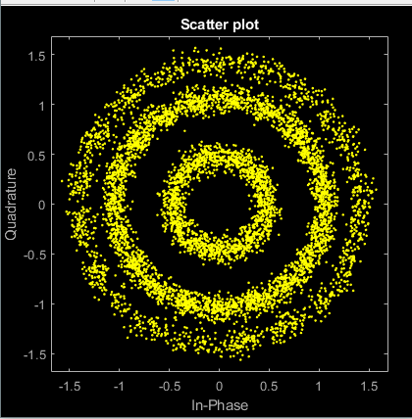

For normalized offset 0.1:

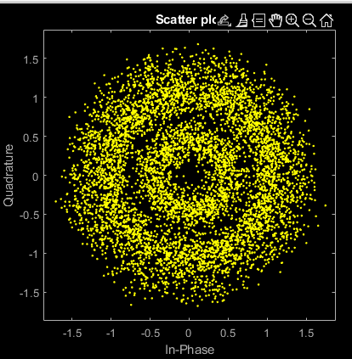

Phase noise effect:

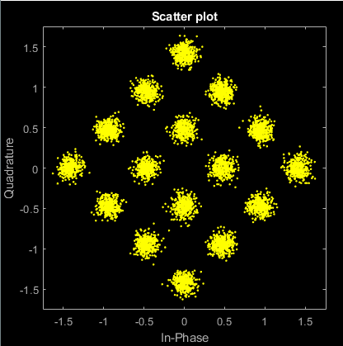

After correcting it:

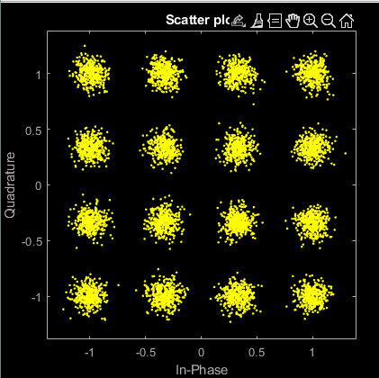

It was corrected using pilots by dividing by the expected value and the value we got thus we were able to obtain an estimate for the phase offset

**Multipath effect:**

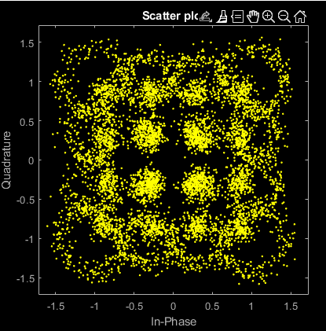

this channel was [10,2,1.5]

which is more like a line of sight scenario

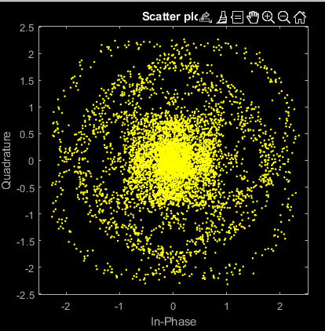

This channel was [2,2,2.5] this was a severe channel

And there was no equalization as far as the write knows cyclic prefix itself won’t help solve this problem without proper equalization as the thing that that the cyclic prefix does is addd an extra part that turns the convolution with the channel into circular convolution which is the DFT of the channel multiplied by the signal

After channel equalization

Zero forcing:

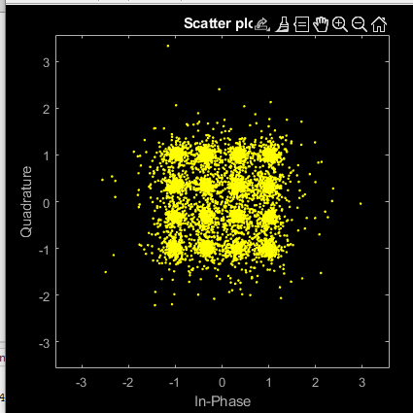

Wiener Filter:

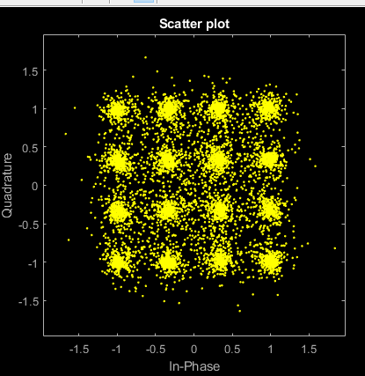

Note that the wiener filter result should be better since it also considers noise however to be honest I am getting very close results with the wiener having a higher error even though it looks better this problem needs further investigation

Question: Student add CP with length more than needed length, what are the advantage

and disadvantage of this behavior?

The advantages is that you get better results when equalizing the signal but this is a wasted power and rate so in ideal world you would be faster than this